Bahria University,

Karachi Campus



LAB EXPERIMENT NO.

_______5_______

LIST OF TASKS

|  |  |
| --- | --- |
| TASK NO | OBJECTIVE |
| 1 | **Using python implement Naïve Bayes with two different splitting ratios on Heart Attack Analysis & prediction dataset to predict the chances of heart failure in a person and performed the following steps:**  * **Data Pre-processing step** * **Fitting Naive Bayes to the Training set** * **Predicting the test result** * **Test accuracy of the result(Creation of Confusion matrix)** * **Visualizing the test set result.**   **Compare the accuracies** |
| 2 | **Design a workflow with the help of Knime to predict whether a user buys a product by clicking the ad on the site based on their salary, age, and gender dataset provided in the lab (i.e. Social network ad dataset).** |

Submitted On:

___________

(Date: 02/05/23)

**LAB # 05**

**Task # 1: Using python implement Naïve Bayes with two different splitting ratios on Heart Attack Analysis & prediction dataset to predict the chances of heart failure in a person and performed the following steps:**

* **Data Pre-processing step**
* **Fitting Naive Bayes to the Training set**
* **Predicting the test result**
* **Test accuracy of the result (Creation of Confusion matrix)**
* **Visualizing the test set result.**

**Compare the accuracies.**

**Solution:**

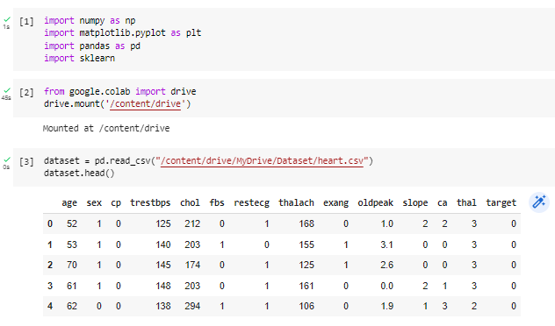

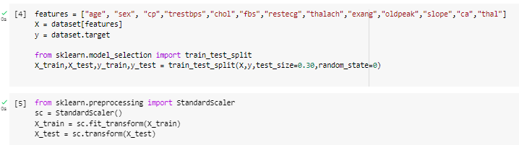

|  |  |
| --- | --- |
| **When test size is 30%** | **When test size is 40%** |
|  |  |

**CONFUSION MATRIX**

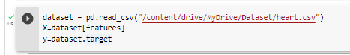

**Task # 2: Design a workflow with the help of Knime to predict whether a user buys a product by clicking the ad on the site based on their salary, age, and gender dataset provided in the lab (i.e. Social network ad dataset).**

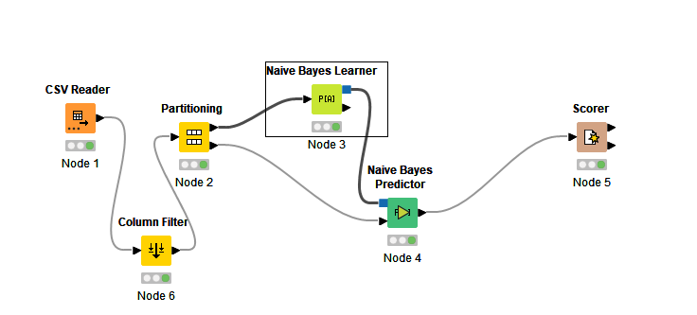**Solution:**

**Output:**

